LAKE FRONT CONDOMINIUMS

ON EVANS LAKE ~ IRISH HILLS

***$329,999***

**Condo Unit #2**

Year Built: 1948

2 Bedrooms

1 Full Bathroom

Approx. 865 sq. ft.

Turnkey, fully furnished Newly Renovated

Forced Air Heat

Air Conditioning PTAC

Metal Roof

Tile Shower

LVT Flooring

Granite Countertops

Kitchen Appliances

Island/Bar

Wood Fireplace

Laundry hook-up

Covered Porch

Slab

Attic storage

Natural Gas, Sewer, Well

Dock Slip

Private Sandy Beach

Two Parking Spaces

Private Boat Launch

Lake Association

Condo Association

(HOA Fees $248/monthly)

*Future opportunity to purchase Garage/Storage units across the street on US-12. Available 2025

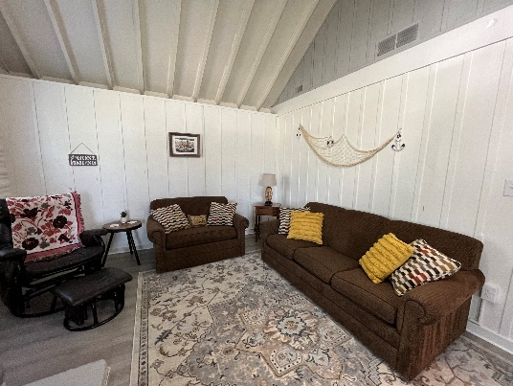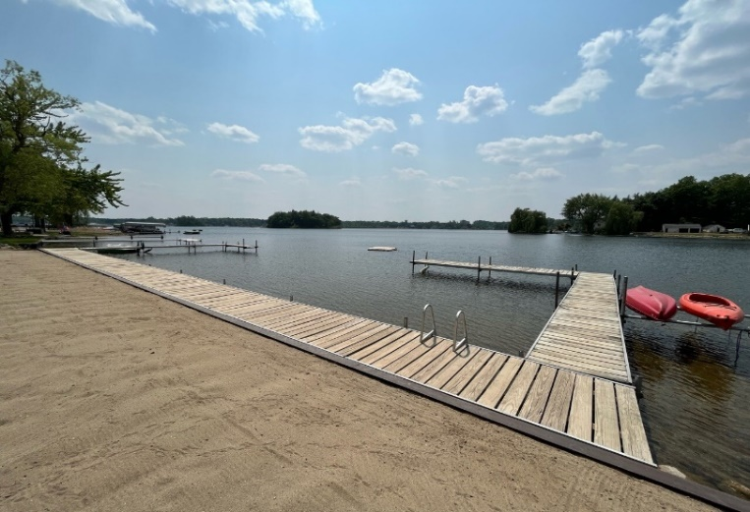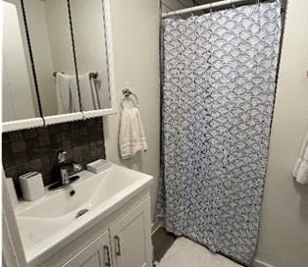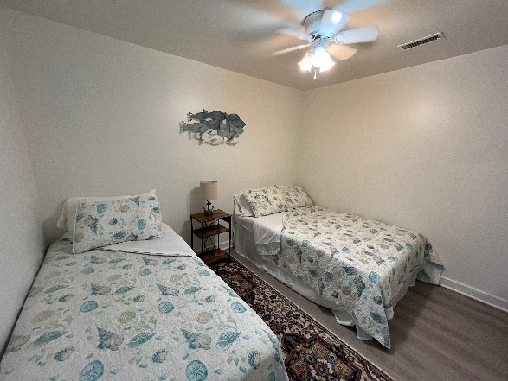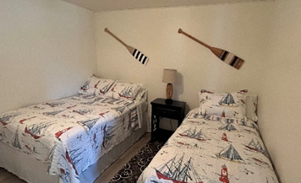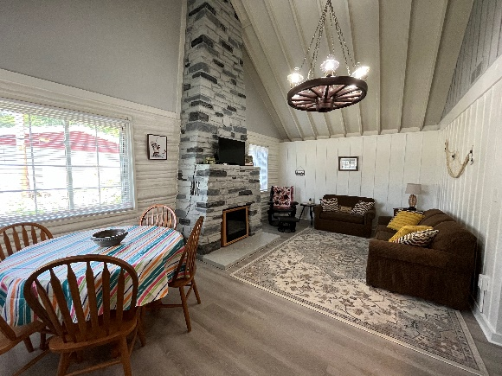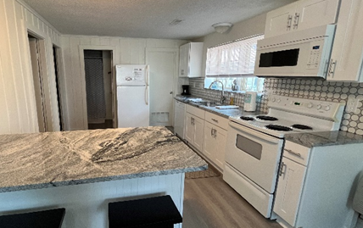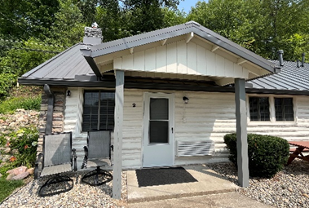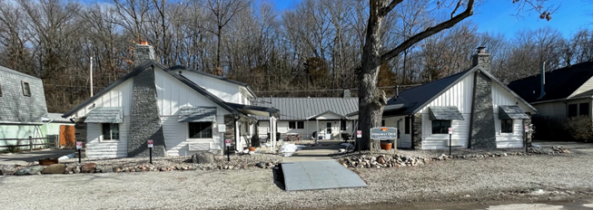

**11558 BREYMAN HWY - TIPTON, MI 49287**

*Please call for private viewings or questions*

**517-431-2594**

Kaylee Welt, Property Manager

[Info@HideawayCoveResort.com](mailto:Info@HideawayCoveResort.com)

www.HideawayCoveResort.com

For

**SALE**

By Owner